2024 USIBA NATIONAL TOURNAMENT RULES
Register with USA Boxing | Required
Full-Time College Student | Required
Headgear | Required
Gloves | 12 oz. (National Championship)
# of Rds/Min. | 3 Rounds of 2 mins (Nationals)
Compulsory Count Limits | 3 in a Round, 4 in a Bout
National Tournament Weight Categories | Men  113  119  125  132  140  147  154  160  168  175  188  201  225  225+ | Women  106  112  119  125  132  141  152  165  178  178+
National Tournament  Divisions | 0-2 Bouts = Beginner  0-9 Bouts = Novice  10,or more Bouts (5+ optional) = Open  *Boxers are eligible for Beginner Division for one year*
National Tournament  Weight Allowances | Day 1: no allowance  Day 2: 1 pound  Day 3: 2 pounds
Team Scoring at National  Tournament | Registered teams of 6 or more boxers from the same academic institution may compete for a team title. Check USIBA website for information and stipulations.
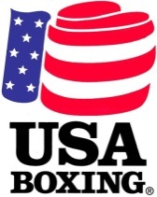
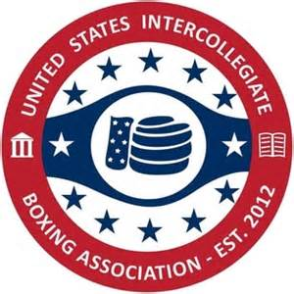

ADDITIONAL REMINDERS FOR COLLEGE BOXERS
Uniform Rule: | No binding material (Such as tape) permitted on the sleeveless shirt nor shorts. Waistband of shorts must be a different color than the sleeveless shirt. Shorts may not extend past top of knee.
Protectors: | Men boxers are required to wear a groin protector. Protectors are optional for women boxers.
Weigh-In & Physicals: | All boxers weigh on the first day of the tournament, otherwise boxers weigh in only on the days in which they are scheduled to compete.
Hair: | Hair must be contained beneath the headgear. Boxers with long hair must wear a cap or net.
Facial Hair: | No beards below shoulder length.
Piercings: | All jewelry, including earrings, nose rings, tongue rings, etc., must be removed during bout.
USA BOXING RULE BOOK: https://www.usaboxing.org/usa-boxing-rulebook

